**EXP:-** Design automatic LED Diwali lights such that it only works during night and can generate 2 patterns which can be toggled with switch:

1. Pattern 1- LED blinks with a frequency of 500 msec

b.Pattern 2- LED blinks with a frequency of 1 sec.

**CIRCUIT DIAGRAM:-**

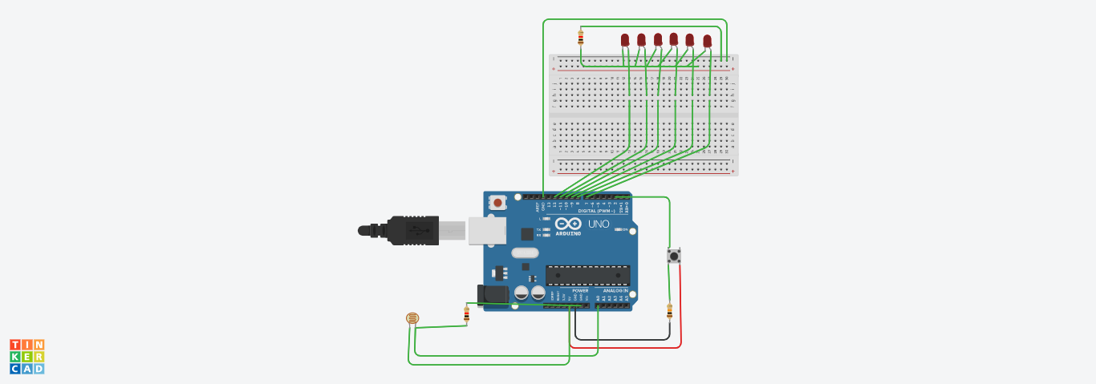

**THEORY:-**

**Concepts used:-**

1.A light dependent resistor (LDR) or a photoresistor is a device whose resistivity is a function of the incident electromagnetic radiation.

2.An electric switch that interrupts the electron flow in a circuit.

3. The arduino board can supply a power of 5V as digital output signals through 14 pins present in it as digital input or output pins.

**Learning and observations:-**

1.I learnt about different components in an Arduino.

2.The basic importance of Arduino was known.

3.I also learnt the function of LDR in controlling brightness of LED..

**Problems & troubleshooting :-**

1.The connecting wires may not be connected properly.

2.There may be some error in writing program.

3. Wrong attachment of wires in terminals of breadboard.

**Precautions:-**

1.Attach the USB cable and connecting wires carefully.

2.Once the USB cable has been inserted then the Arduino connected to the USB cable should not be touched with bare hands.

**Learning outcomes:-**

1.I learnt how to make connections using breadboard and Arduino.

2.I learnt how to use LDR and control the brightness along with using a switch.